Tables used in this note:

Sailors (sid: integer, sname: string, rating: integer, age: real);

Boats (bid: integer, bname: string, color: string);

Reserves (sid: integer, bid: integer, day: date);

**Sailors**

|  |  |  |  |
| --- | --- | --- | --- |
| **SID** | **SNAME** | **RATING** | **AGE** |
| 22 | Dustin | 7 | 45 |
| 29 | Brutus | 1 | 33 |
| 31 | Lubber | 8 | 55.5 |
| 32 | Andy | 8 | 25.5 |
| 58 | Rusty | 10 | 35 |
| 64 | Horatio | 7 | 35 |
| 71 | Zorba | 10 | 16 |
| 74 | Horatio | 9 | 40 |
| 85 | Art | 3 | 25.5 |
| 95 | Bob | 3 | 63.5 |

**Boats**

|  |  |  |
| --- | --- | --- |
| **BID** | **BNAME** | **COLOR** |
| 101 | Interlake | blue |
| 102 | Interlake | Red |
| 103 | Clipper | green |
| 104 | Marine | Red |

**Reserves**

|  |  |  |
| --- | --- | --- |
| **SID** | **BID** | **DAY** |
| 22 | 101 | 10-OCT-98 |
| 22 | 102 | 10-OCT-98 |
| 22 | 103 | 08-OCT-98 |
| 22 | 104 | 07-OCT-98 |
| 31 | 102 | 10-NOV-98 |
| 31 | 103 | 06-NOV-98 |
| 31 | 104 | 12-NOV-98 |
| 64 | 101 | 05-SEP-98 |
| 64 | 102 | 08-SEP-98 |
| 74 | 103 | 08-SEP-98 |

CREATE TABLE Sailors (

sid NUMBER PRIMARY KEY, -- Sailor ID (integer)

sname VARCHAR2 (15) NOT NULL, -- Sailor's name (string)

rating NUMBER (3) NOT NULL, -- Rating (integer)

age NUMBER (5, 2) -- Age (real number, with two decimal points)

);

CREATE TABLE Boats (

bid NUMBER PRIMARY KEY, -- Boat ID (integer)

bname VARCHAR2 (15) NOT NULL, -- Boat name (string)

color VARCHAR2 (50) -- Boat color (string)

);

CREATE TABLE Reserves (

sid NUMBER, -- Sailor ID (foreign key)

bid NUMBER, -- Boat ID (foreign key)

day DATE, -- Date of reservation

PRIMARY KEY (sid, bid, day), -- Composite primary key (sid, bid, day must be unique)

FOREIGN KEY (sid) REFERENCES Sailors (sid), -- Foreign key from Sailors table

FOREIGN KEY (bid) REFERENCES Boats (bid) -- Foreign key from Boats table

);

INSERT INTO Sailors (sid, sname, rating, age) VALUES (22, 'Dustin', 7, 45);

INSERT INTO Sailors (sid, sname, rating, age) VALUES (29, 'Brutus', 1, 33);

INSERT INTO Sailors (sid, sname, rating, age) VALUES (31, 'Lubber', 8, 55.5);

INSERT INTO Sailors (sid, sname, rating, age) VALUES (32, 'Andy', 8, 25.5);

INSERT INTO Sailors (sid, sname, rating, age) VALUES (58, 'Rusty', 10, 35);

INSERT INTO Sailors (sid, sname, rating, age) VALUES (64, 'Horatio', 7, 35);

INSERT INTO Sailors (sid, sname, rating, age) VALUES (71, 'Zorba', 10, 16);

INSERT INTO Sailors (sid, sname, rating, age) VALUES (74, 'Horatio', 9, 40);

INSERT INTO Sailors (sid, sname, rating, age) VALUES (85, 'Art', 3, 25.5);

INSERT INTO Sailors (sid, sname, rating, age) VALUES (95, 'Bob', 3, 63.5);

INSERT INTO Boats (bid, bname, color) VALUES (101, 'Interlake', 'blue');

INSERT INTO Boats (bid, bname, color) VALUES (102, 'Interlake', 'red');

INSERT INTO Boats (bid, bname, color) VALUES (103, 'Clipper', 'green');

INSERT INTO Boats (bid, bname, color) VALUES (104, 'Marine', 'red');

INSERT INTO Reserves (sid, bid, day) VALUES (22, 101, TO_DATE('1998-10-10', 'YYYY-MM-DD'));

INSERT INTO Reserves (sid, bid, day) VALUES (22, 102, TO_DATE('1998-10-10', 'YYYY-MM-DD'));

INSERT INTO Reserves (sid, bid, day) VALUES (22, 103, TO_DATE('1998-10-08', 'YYYY-MM-DD'));

INSERT INTO Reserves (sid, bid, day) VALUES (22, 104, TO_DATE('1998-10-07', 'YYYY-MM-DD'));

INSERT INTO Reserves (sid, bid, day) VALUES (31, 102, TO_DATE('1998-11-10', 'YYYY-MM-DD'));

INSERT INTO Reserves (sid, bid, day) VALUES (31, 103, TO_DATE('1998-11-06', 'YYYY-MM-DD'));

INSERT INTO Reserves (sid, bid, day) VALUES (31, 104, TO_DATE('1998-11-12', 'YYYY-MM-DD'));

INSERT INTO Reserves (sid, bid, day) VALUES (64, 101, TO_DATE('1998-09-05', 'YYYY-MM-DD'));

INSERT INTO Reserves (sid, bid, day) VALUES (64, 102, TO_DATE('1998-09-08', 'YYYY-MM-DD'));

INSERT INTO Reserves (sid, bid, day) VALUES (74, 103, TO_DATE('1998-09-08', 'YYYY-MM-DD'));

Queries:

1. Find all information of sailors who have reserved boat number 101.

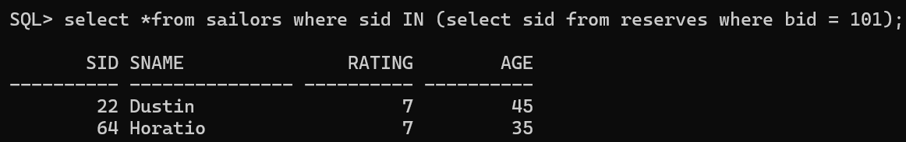

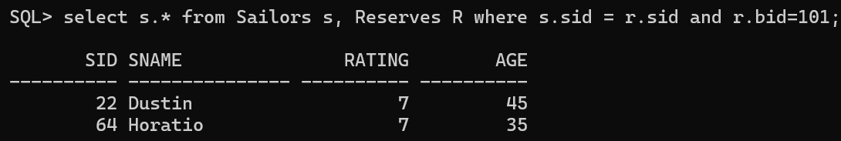

1. Find the names of sailors who have reserved a red boat, and list in the order of age.

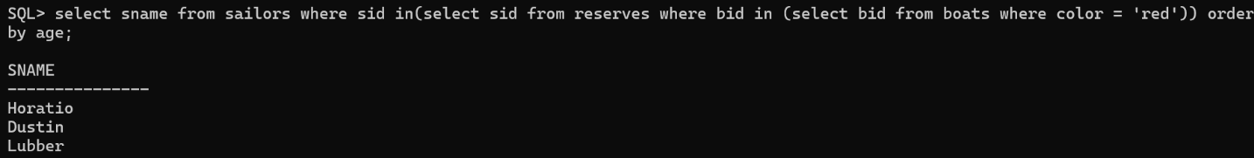

1. Find the names of sailors who have reserved at least one boat.

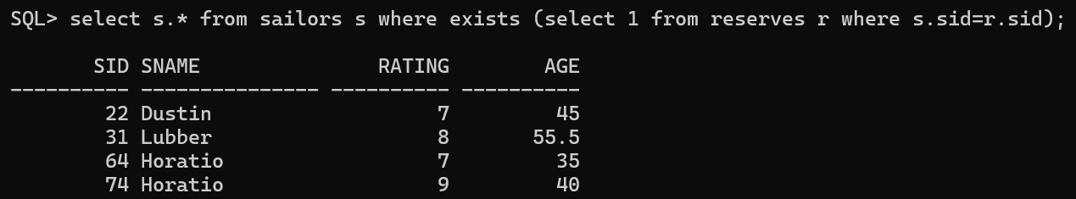

1. Find the ids and names of sailors who have reserved two different boats on the same day.



1. Find the ids of sailors who have reserved a red boat or a green boat (Using IN, EXISTS, UNION)

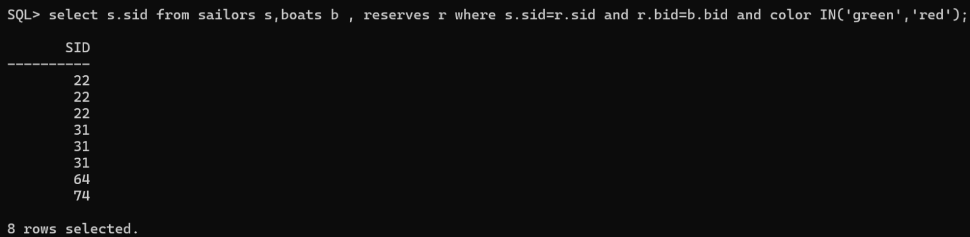

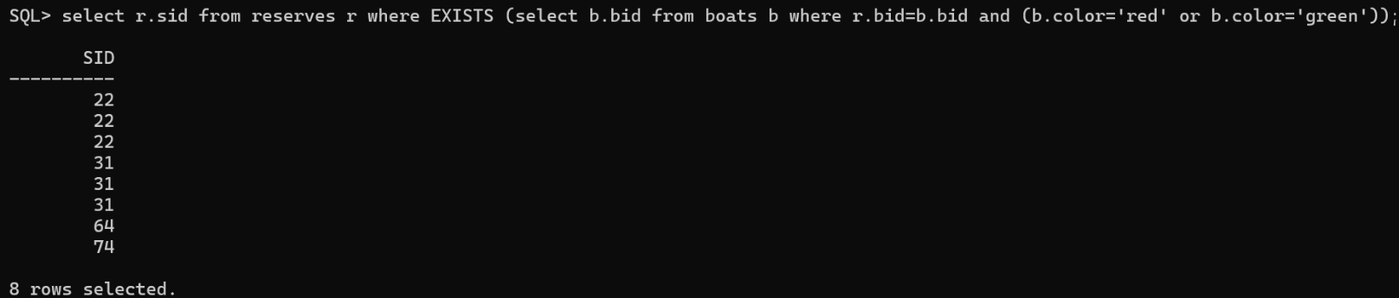

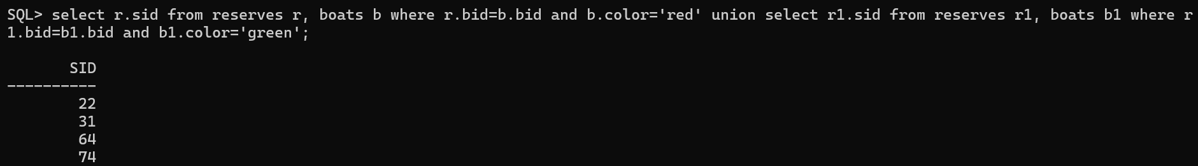

1. Find the names of sailors who have reserved boat 103.

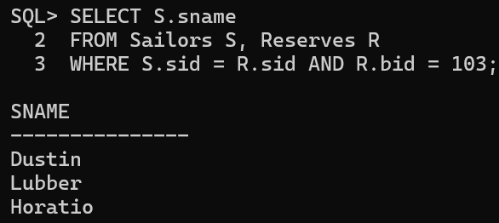

1. Find the names of sailors who have reserved boat 103 using IN operator.

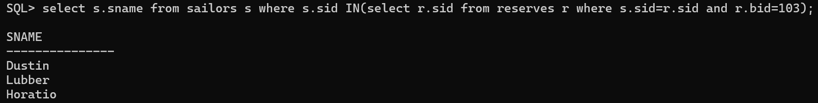

1. Find the names of sailors who have reserved boat 103 using EXISTS Operator.

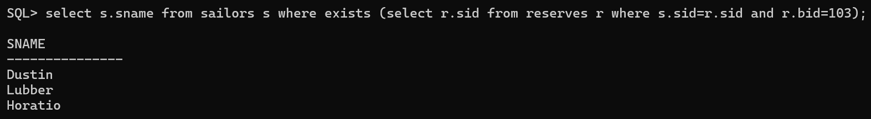

1. Find sailors whose rating is better than some sailor called ‘BOB’ using ANY Operator.

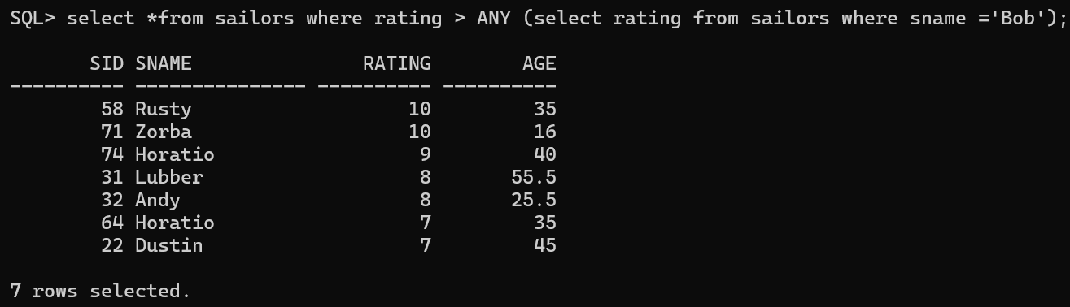

1. Find the sailor's with the highest rating using ALL Operator.

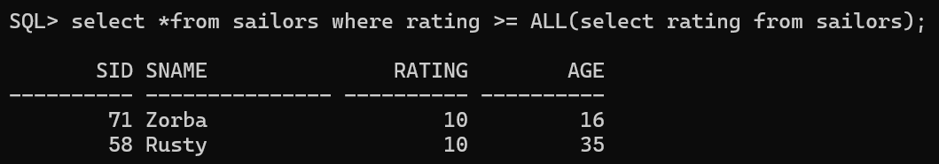

1. Find the name and the age of the youngest sailor.

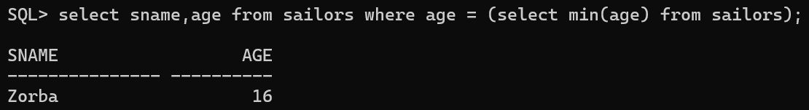

1. Find the names and ratings of sailors whose rating is better than sailor called Horatio.

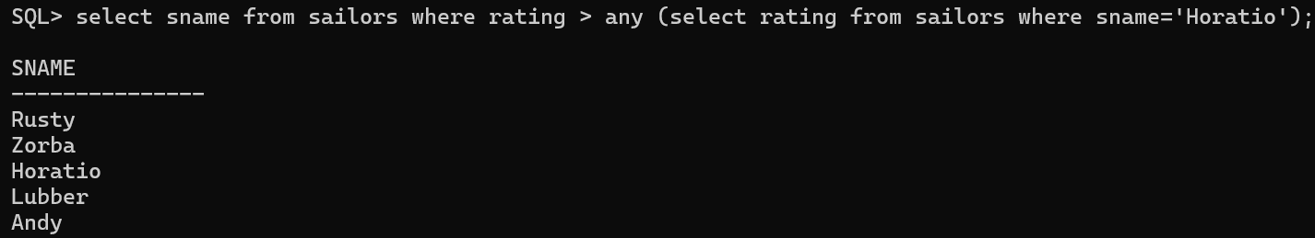

1. Count the number of different sailor names.

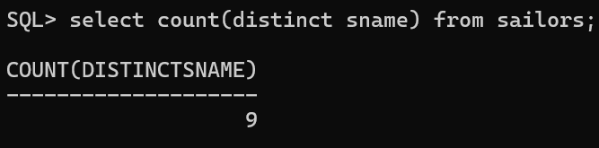

1. Calculate the average age of all sailors.

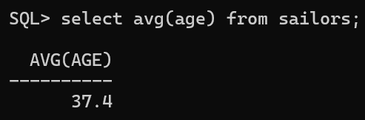

1. Find the name and the age of the youngest sailor using aggregate function.

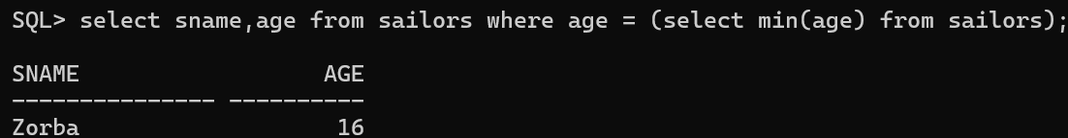

1. Find the average age of sailors for each rating level.

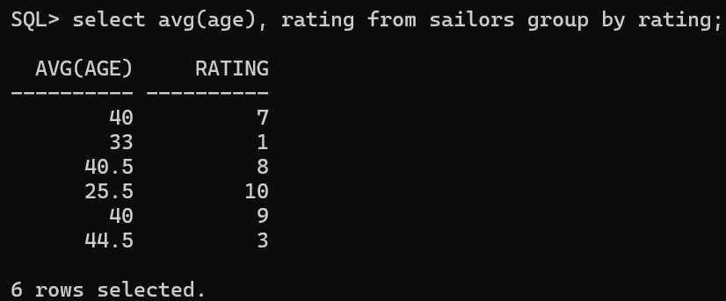

1. Find the average age of sailors for each rating level that has at least two sailors.

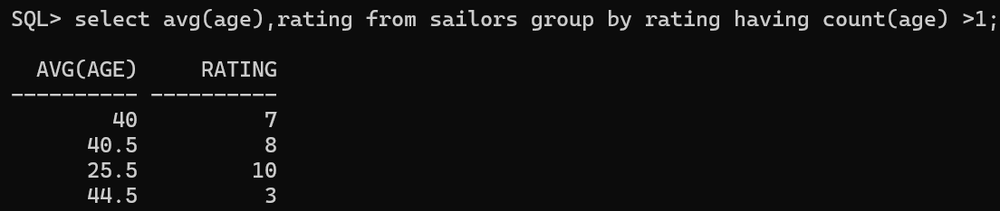

1. Find all Sid’s of sailors who have a rating of 10 or reserved boat number 103.

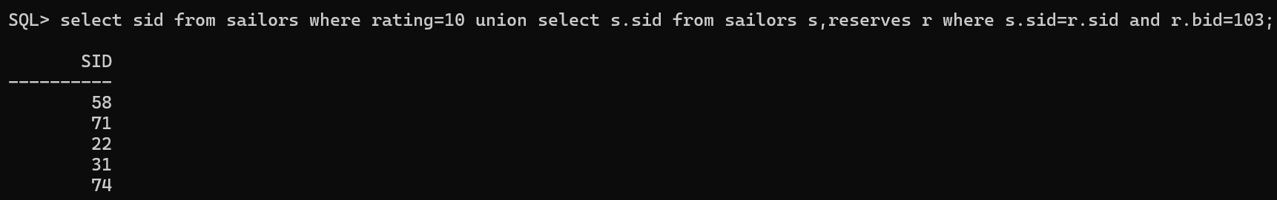

1. Find the names of sailor's that have reserved both a red and a green boat.

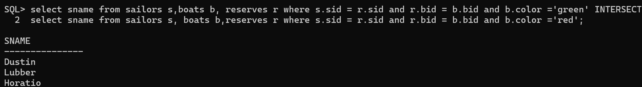

1. Find the names of sailors who have not reserved boat number 103.

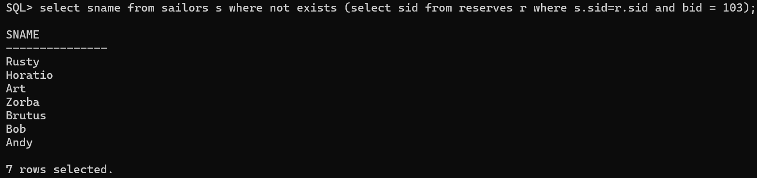

select sailors.* from sailors, reserves where sailors.sid=reserves.sid and reserves.bid=103;

SID SNAME RATING AGE

---------- ------------------------------ ---------- ----------

22 Dustin 7 45

31 Lubber 8 55.5

74 Horatio 9 40

select s.sname, b.bname, s.age from sailors s, reserves r, boats b where r.bid=b.bid and s.sid=r.sid and b.color='red' order by s.age;

SNAME BNAME AGE

------------------------------ ------------------------------ ----------

Horatio Interlake 35

Dustin Marine 45

Dustin Interlake 45

Lubber Interlake 55.5

Lubber Marine 55.5

select s.sname from sailors s, reserves r where s.sid=r.sid;

SNAME

------------------------------

Dustin

Dustin

Dustin

Dustin

Lubber

Lubber

Lubber

Horatio

Horatio

Horatio

10 rows selected.

select distinct s.sname, s.sid from sailors s, reserves r1, reserves r2 where s.sid=r1.sid and s.sid=r2.sid and r1.bid<>r2.bid and r1.day=r2.day;

SNAME SID

------------------------------ ----------

Dustin 22

select r.sid from reserves r, boats b where r.bid=b.bid and b.color='red' union select r1.sid from reserves r1, boats b1 where r1.bid=b1.bid and b1.color='green';

SID

----------

22

31

64

74

select r.sid from reserves r where exists (select b.bid from boats b where r.bid=b.bid and (b.color='red' or b.color='green'));

SID

----------

64

31

22

74

31

22

31

22

select r.sid from reserves r where r.bid in (select b.bid from boats b where b.color in ('red','green'));

SID

----------

22

22

22

31

31

31

64

74

select s.sid from reserves r, sailors s where r.sid=s.sid and r.bid=103;

SID

----------

22

31

74

select s.sid from sailors s where s.sid in (select r.sid from reserves r where r.bid=103);

SID

----------

22

31

74

select s.sid from sailors s where exists (select r.sid from reserves r where s.sid=r.sid and r.bid=103);

SID

----------

22

31

74

select sname from sailors where rating > any (select rating from sailors where sname='Bob');

SNAME

------------------------------

Rusty

Zorba

Horatio

Lubber

Andy

Horatio

Dustin

select sname from sailors where rating >= all (select rating from sailors);

SNAME

------------------------------

Zorba

Rusty

select sname,age from sailors where age <= all (select age from sailors);

SNAME AGE

------------------------------ ----------

Zorba 16

select sname from sailors where rating > any (select rating from sailors where sname='Horatio');

SNAME

------------------------------

Rusty

Zorba

Horatio

Lubber

Andy

select count(sname) from sailors;

COUNT(SNAME)

------------

10

select avg(age) from sailors;

AVG(AGE)

----------

37.4

select sname,age from sailors where age=(select min(age) from sailors);

SNAME AGE

------------------------------ ----------

Zorba 16

select s.rating,avg(s.age) from sailors s group by (s.rating);

RATING AVG(S.AGE)

---------- ----------

1 33

8 40.5

7 40

3 44.5

10 25.5

9 40

select s.rating,avg(s.age) from sailors s group by (s.rating) having count(*)>1;

RATING AVG(S.AGE)

---------- ----------

8 40.5

7 40

3 44.5

10 25.5

select sid from sailors where rating=10 union select s.sid from sailors s,reserves r where s.sid=r.sid and r.bid=103;

SID

----------

22

31

58

71

74

select s.sname from sailors s, reserves r,boats b where r.sid=s.sid and r.bid=b.bid and b.color='red' intersect select s.sname from sailors s, reserves r, boats b where b.bid=r.bid and s.sid=r.sid and b.color='green';

SNAME

------------------------------

Dustin

Horatio

Lubber

select s.sname from sailors s where not exists (select * from reserves r where r.sid=s.sid and r.bid=103);

SNAME

------------------------------

Brutus

Andy

Rusty

Horatio

Zorba

Art

Bob